When and where were you born?



What is your full name and why was that name chosen for you?

What are the names of your parents and siblings?

Are you the oldest, middle or youngest child?

How did this affect you as you were growing up?

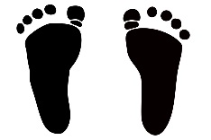

Where did your family come from?

What is interesting or unusual about your background?



What do you remember most about your father, mother and grandparents?



Share some memories about your brothers and sisters.



What did your family do for fun when you were a child?

Where did your go-on vacations?



Were you close to anyone in your extended family when you were growing up?

What do you remember about the house you grew up in?



What was your life like as a child?

What kinds of things did you like to do as a child?



Did you have any health problems as a child?

Did you ever get into trouble as a child?

How did your parents react?



What were some of your favorite experiences as a child?



What interests and talents did you have as a child?

What were some of your family traditions that you liked or disliked? Why?



How is life different today, compared to when you were a child?



Where did you go to elementary, junior high and high school?

Who were your favorite teachers?

What was school like for you?

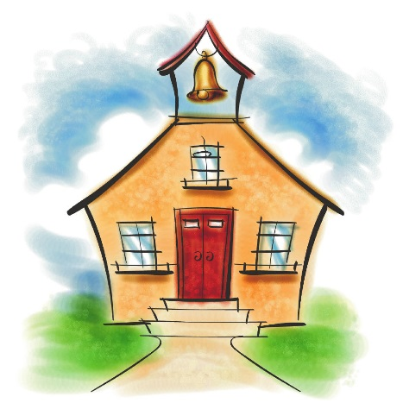



What were your favorite subjects?

What did you want to be when you grew up?

How did that change over the years?

Who were your friends during your school years?

What did you do, where did you go?





What teams or clubs did you belong to?

Did you participate in other activities?

What hobbies and interests have you had over the years?'



What responsibilities did you have at home or in the community?

Did you like to read? If so, what types of books did you enjoy?



What was the biggest influence in your early years?

Did you have someone you looked up to for advice?

In what ways did he/she change your life?

What was the name of the first boy/girl you liked?

Who did you go on your first date with?

Describe your personality at this time in your life.



When did your first leave home?

Where did you go?

What goals did you have?

What important historical events occurred during your early childhood?



What were some of the challenges you faced during this time?



What were some of the triumphs you experienced?



What was your first-job and-what kinds of jobs have you had?

What was your wage?



Did you serve in the military?

If so, when and in which branch?

What did you do?



How did you meet your spouse?

What did you like best or find most attractive about your spouse?

What was your dating and engagement like?





Describe your wedding day.



What was life like as a young couple?

How did you both have to change?

What are the names of your children?

Are there, any special stories about their pregnancies and/or births?



What did you enjoy doing with your family?

What did you admire most about your spouse?

What are your favorite memories together?

What are some of the funny things your children did when they were growing up?

What is the most difficult part about being a parent?

What is the best?

What advice would give on being a parent?

What would you change about the way you raised your own children?

What special awards of recognition have you received?



What strengths do you have?

What skills did you acquire?

What are your interests and hobbies now?



What are some of the greatest challenges you have had to face?

How did you hear about the death of your parents?

What were your feelings?

Who are your oldest and dearest friends?

What do you remember most about them?



What are your feelings about being a grandparent?



How did your spouse die?

What is the single most important event that occurred in your lifetime?

What has been your favorite place to visit?

Why?



What has been your greatest adventure?

What have you learned from your life experience?

What do you think are the biggest problems our country is dealing with now?



What were the hardest choices you have had to make in your life?

What would you change about your life if you could?

What advice do you have for your posterity?

What have you always wanted to do but never done?

What do you want people to remember about your life?